

**Article Name**

Error bar in python chart

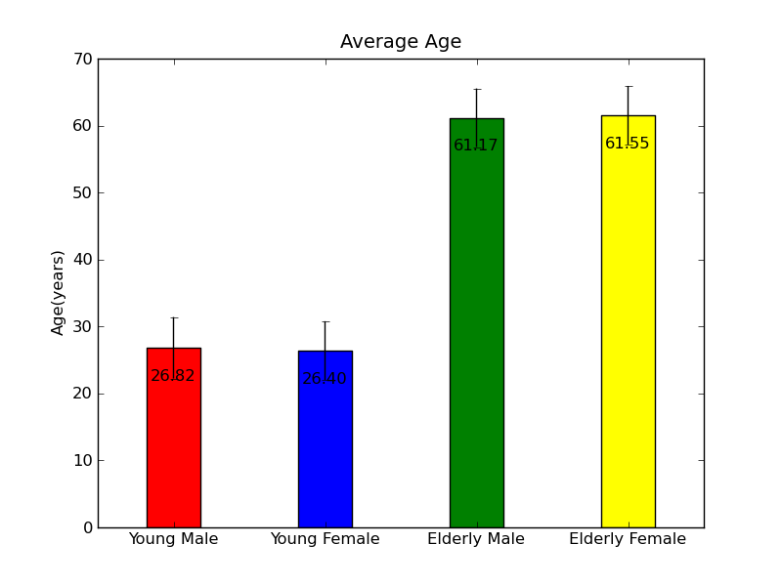

**Name: Menna Mohamed Zainhom**

Error bar:

Error dashboards are graphic representations of data variability and are used in graphs to indicate the error or uncertainty of a reported measurement. They give a general idea of how accurate the measurement is, or vice versa, how true (error-free) the value may be than the reported value. Error bars often represent one standard deviation of uncertainty, or standard error

Bar charts with error bars are useful in engineering to show confidence or accuracy in a set of calculated measurements or values.

To create a bar chart with error bars for this dataset, we can define the width of the error bars as the **standard error**, which is calculated a

**Standard error = s / √n**

Where:

* **s:**sample standard deviation
* **n:**sample size

Example 1:

Using this line code:

sns.barplot (x=’set’,y=’total_bill’,data=tips)

Example 2:

# Import Library

import matplotlib.pyplot as plt

# Define Data

x= [6, 15, 2.3, 9]

y= [9, 15, 20, 25]

# Define Error

y_error = [2.3, 5.1, 1, 3.1]

# Plot Bar chart

plt.bar(x,y)

# Plot error bar

plt.errorbar(x, y, yerr = y_error,fmt='o',ecolor = 'red',color='yellow')

# Display graph

plt.show()